Vote Application based on iOS Requirement Document

Current Version: v1.0

Author: Jianghua Kuai, Shuai Zhao

Oct 11, 2013Maintenance History

|  |  |  |  |
| --- | --- | --- | --- |
| **Author** | **Date** | **Content** | **Version** |
| **Jianghua Kuai** | Oct 11, 2013 | Build the Document | V0.1 |
| **Shuai Zhao** | Oct 12, 2013 |  | V0.2 |
| **Jianghua Kuai**  **Shuai Zhao** | Oct 13, 2013 | Add use case and finish the doc | V1.0 |

Table of Contents

1. Purpose and scope 4

**1.1 Purpose………………………………......................................................................................4**

**1.2 SCOPE** **………………………………...........................................................................................4**

2. Market assessment and target demographics 4

3. Product overview and use cases 5

4. Requirements 5

**4.1 Functional Requirement……………………….....................................................5**

**4.1.1 User MANAGEMENT………………………................................................................5**

**4.1.2 VOte initiation………………………......................................................................6**

**4.1.3 vote searching………………………......................................................................6**

**4.1.4 vote operation……………………….....................................................................6**

**4.1.5 exception handling………………………............................................................7**

**4.1.6 notification push………………………................................................................7**

**4.1.7 view vote history………………………...............................................................7**

**4.2 Usability requirement………………………..........................................................8**

**4.3 Technical requirement………………………........................................................8**

**4.4 Environmental requirement………………………...........................................8**

**4.5 Performance requirement………………………................................................8**

5. Priority and Risks 8

6. Appendix 9

# Purpose and scope

* 1. Purpose

This application is designed to replace the regular time-consuming paper-based vote. People can efficiently initiate or participate in a particular vote in this application. And the result will be analyzed and be pushed back to every participant’s iPhone instantly after everyone finishes his or her votes. Meanwhile, it evidently enhances the trustworthiness of the vote, since the possibilities of tellers’ interference are gone. Furthermore, the vote will be totally anonymous because the encrypted message transferring from client to serve is more safety than the handwriting that can be differentiated by tellers.

* 1. Scope

The app will release on Appstore without region restriction, and the language will be English only.

The application will only implement on the iOS platform on iPhone device and the server will run on CentOS 6.4 64bit. The prototype may not include the UI design.

For the UI design in release version, since the iOS7 is changed to the flat design style, the design of user interface of this application will also be flat to accommodate with the iOS7.

# Market assessment and target demographics

Although there are several applications existing in IOS, but the interesting fact is people tend to choose paper-based vote when they have to vote. A lot of them are designed for particular events such as US presidential election. And many others are too complicated to use. They are just like creating new social networks. However, we just want to use it to vote instead of joining another social network. Other voting application is offline. That is to say, bunches of people use only one device to complete voting, which is inconvenient and inefficient.

The client use case is as below.

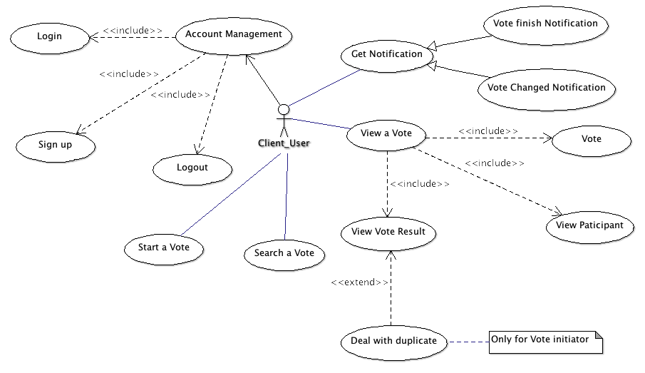

# Product overview and use cases

This application can be used in many occasions such as meeting, classroom, and party and so on so forth. Anyone could start a vote in this application. Then the vote event will be created with a password with which people are eligible to vote. Every people around this particular site can find this vote event on his or her application. If it doesn’t work, its unique ID can also search this vote event. Every participant’s name will be showed in the application. And of course, the detailed choices of everyone will not be showed. The result will be pushed to everyone’s application simultaneously after the last voter made his or her decision.

# Requirements

1. Functional requirement
2. User Management

Requirement ID: F00001

Description: Every user should have a legal account to use this application. User’s name, Email address and PIN are required when anyone sign up for an account. After entering Email authentication code, the user could successfully log in. If user already has an existing account, he or she could log in this application on anyone’s iPhone after last user log out.

1. Vote initiation

Requirement ID: F00002

Description: Anyone who wants to launch a new vote should follow the tips given by the application. The initiator should give the subject of the vote, every option of the vote, and the total number of the applicants, available time period and the password for everyone who is permitted to participate in this vote. When initiator submits this vote, the location will be recorded automatically.

1. Vote searching

Requirement ID: F00003

Description: Every neighborhood vote event, based on the place where he or she is, within valid time will be shown in the searching result page in the application. And according to additional information such as the vote event ID, the initiator’s name and the subject, the user could choose the particular one that he or she should attend. If the location-based search is failed, users could also choose to search the vote event by vote event ID, which will be created when the vote is initiated.

1. Vote operation

Requirement ID: F00004

Description: Entering the correct password, users could vote in the application within the valid time period.

1. Vote Exception handling

Requirement ID: F00005

Description: There are some unexpected occasions we should take into consideration. If there are two or more participants with the same name in one vote event, these conflicts will be settled by the initiator. He should figure out if there are more than one people actually having the same name. If it is the case, he should valid all these votes. But if not, he also should differentiate the real one by checking his or her address. Then the votes with faked same name will be eliminated from this vote event.

1. Notification push

Requirement ID: F00006

Description: After every participant finish their vote or the valid vote time is over, if the exception happens, there will be a notification pushing to the initiator’s iPhone and let him or her handle this problem. After that the end notification will be pushed to every participant’s iPhone to inform that the vote’s result could be checked in the application.

1. View Vote History

Requirement ID: F00007

Description: User could view the vote history list, which shows that the vote user is involved. User could check the result of vote that has been finished. Every vote result includes following message: 1.The verification that your vote is included in the final result in case the initiator make a mistake when handles the exception. 2. The total number of supporters of each option of this vote. 3.The entire number of all participants and everyone’s name.

1. Usability requirements

The application can be used in many occasions mostly when people are in the same area. Some examples are given as follows: students can use it to elect their class leader; people can choice their desired plan during business; family members can make the decision that where to go during the vacation.

1. Technical requirements

The message transferring from device to the server will definitely be encrypted. And the exception handling is also taken into consideration.

The application will use *Google Analytics* to trace the exception of application, and get the active users number.

The server will use Plankton Server as a framework and will modify some features to meet the requirements.

1. Environmental requirements

This application will be developed for iPhone4, iPhone4S, iPhone5, and iPhone5S. And the OS we will support is iOS5.0+.

The IDE for client app will be *Xcode5*, *eclipse CTD* for server app.

The database for server will be *MySQL*.

1. Performance requirements

The user will not wait for more than 10 seconds with any operation.

The client should not use more than 256MB memory at peak.

# Priority and Risks

|  |  |  |
| --- | --- | --- |
| Requirement ID | Priority | Risk |
| F00001 | High | High |
| F00002 | High | Low |
| F00003 | Medium | Low |
| F00004 | Medium | Low |
| F00005 | Low | Medium |
| F00006 | Low | High |
| F00007 | Low | Medium |

# Appendix